DATE: EXPT NO:09 | MINI PROJECT  Social Media Data Analytics

AIM:
To analyze social media data using Python, SQL Server, and Tableau by generating and managing a 20,000-record dataset, performing data analysis, and creating interactive visualizations to identify trends in likes, views, engagement, platforms, and content types.

Software and Tools Required
- Python
- VS Code
- Pandas
- SQL Server
- SQL Server Management Studio (SSMS)
- Tableau Desktop

Process / Procedure
Step 1 — Project Setup Create a project folder: SocialMediaAnalytics
│
├── .venv
├── generate_data.py
├── insert_data.py
└── social_media_data.csv

Create and activate the Python virtual environment.

Step 2 — Create Database
Open SQL Server Management Studio (SSMS) and connect using: Server: localhost
Authentication: Windows Authentication Create the database:
CREATE DATABASE social_media_analytics; GO

Step 3 — Create Table
Create the social_media_data table: USE social_media_analytics;
GO

CREATE TABLE social_media_data ( Post_ID INT PRIMARY KEY,
User_ID INT,
Platform VARCHAR(50), Post_Date DATE, Content_Type VARCHAR(50), Likes INT,
Comments INT, Shares INT, Views INT, Followers INT,

Engagement_Rate DECIMAL(5,2)
);
GO

Step 4 — Generate Dataset Using Python
Python is used to generate exactly 20,000 social media records. The dataset contains:
Post ID User ID Platform Post Date
Content Type Likes Comments Shares
Views Followers
Engagement Rate
The generated data is saved as:
social_media_data.csv

Step 5 — Insert Data into SQL Server
The Python insert_data.py program connects to SQL Server and inserts the generated dataset into the database.
The data flow is:

Python
↓
social_media_data.csv
↓
SQL Server
↓
social_media_analytics
↓
social_media_data

Step 6 — Verify the Dataset Run:
USE social_media_analytics; GO

SELECT COUNT(*) AS total_records FROM social_media_data;
Result:
total_records
-------------
20000
This confirms that all 20,000 records have been successfully stored in SQL Server.

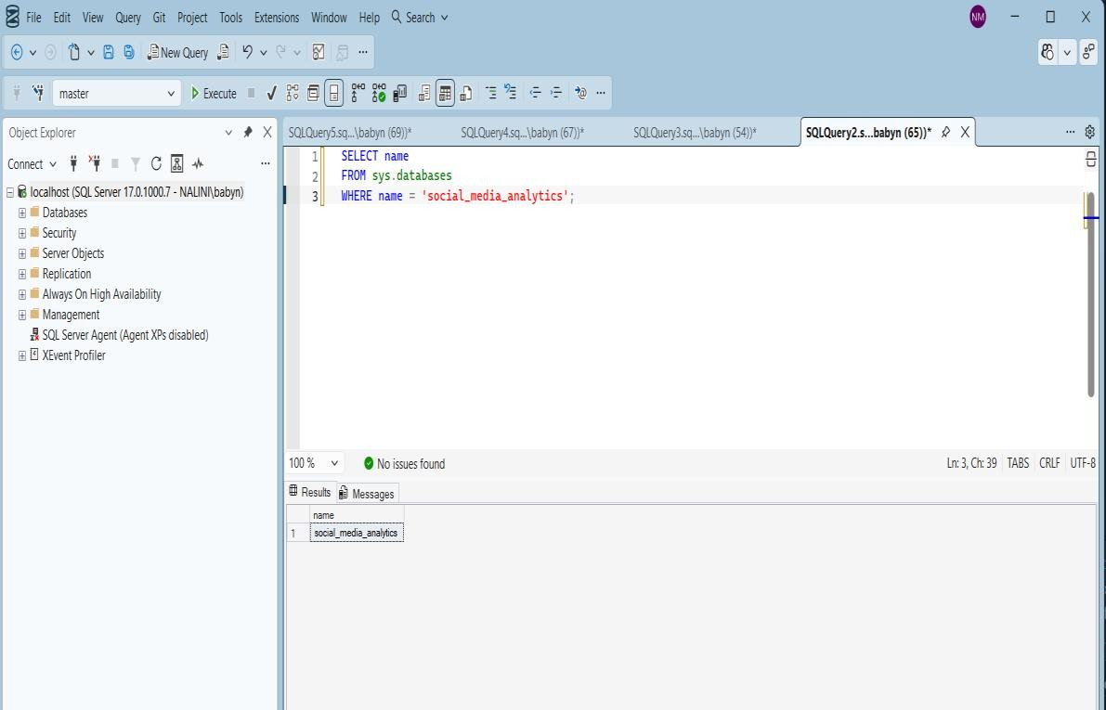

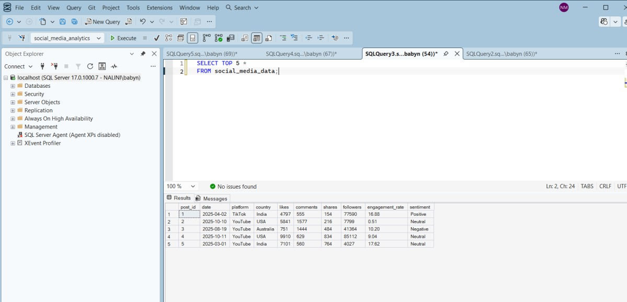

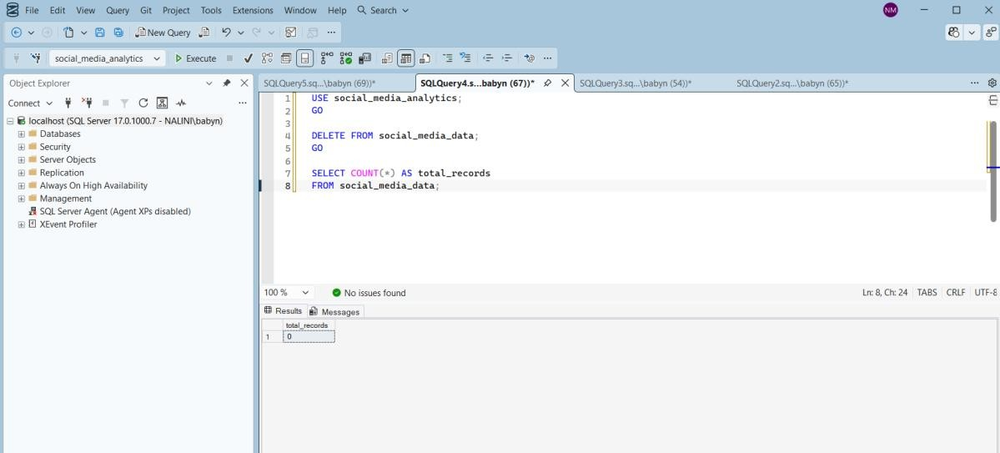

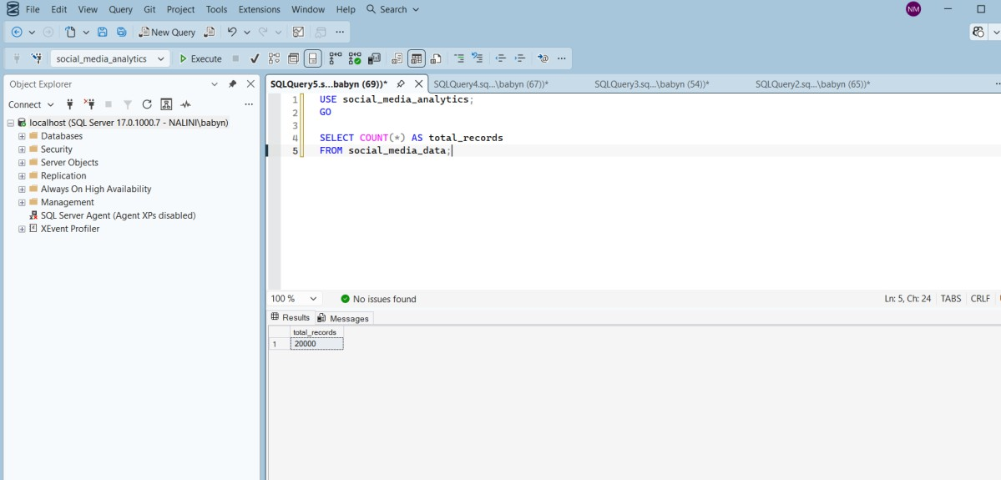

Data Visualization Using Tableau
After storing the dataset in SQL Server, connect Tableau Desktop to: SQL Server
↓
social_media_analytics
↓

social_media_data
Create different visualizations.

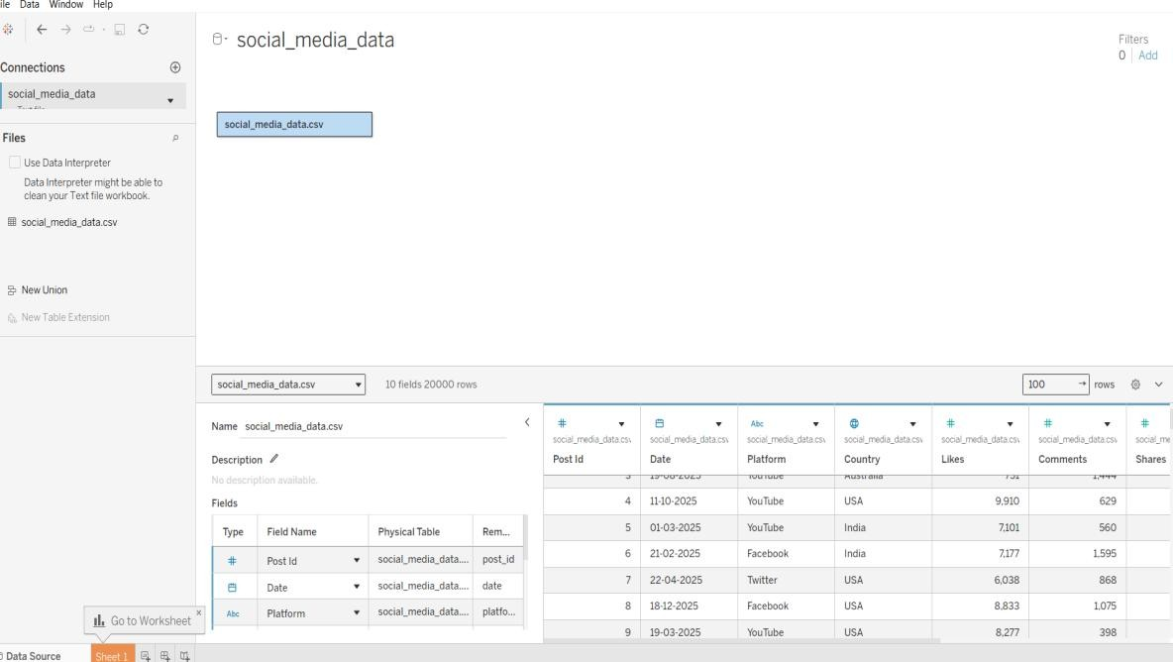
Visualization 1 — Platform-wise Likes Chart: Bar Chart
Shows the total likes received by each social media platform.

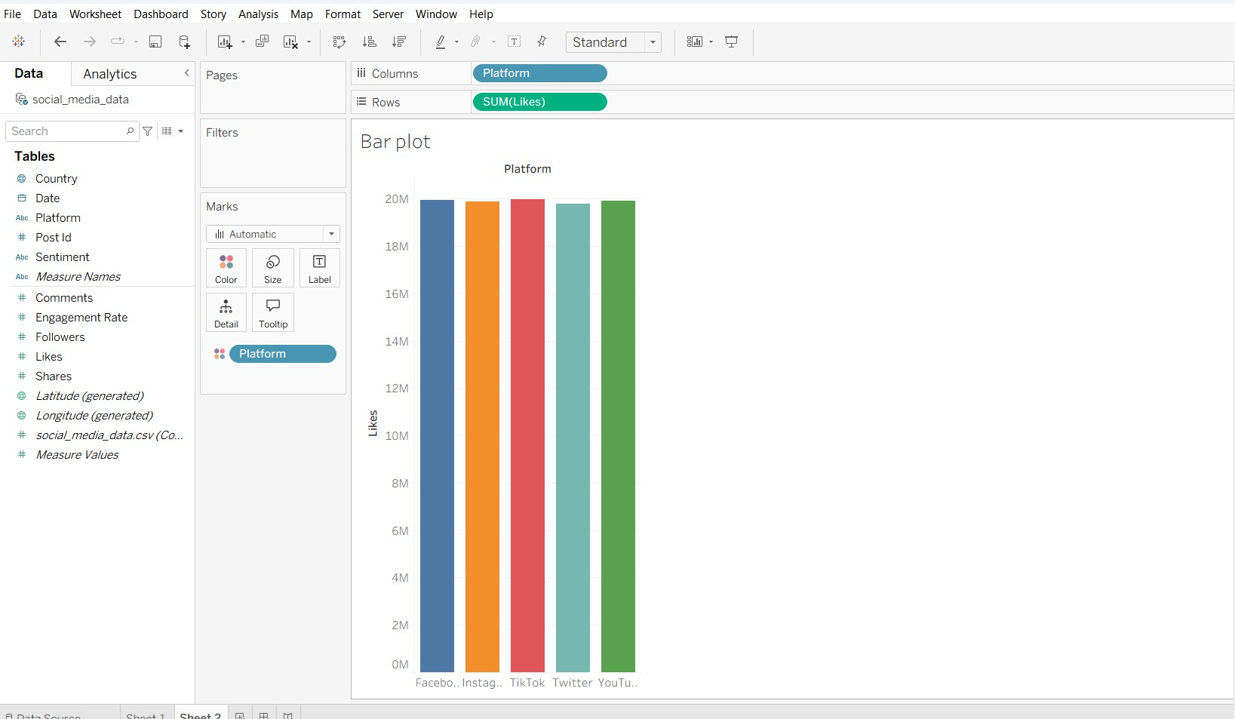

Visualization 2 — Views Trend Chart: Line Chart
Shows how the number of views changes over time.

Visualization 3 — Platform Distribution Chart: Pie Chart
Shows the distribution of posts among different platforms.

Visualization 4 — Engagement Rate Chart: Histogram
Shows the distribution of engagement rates across the dataset.

Visualization 5 — Engagement Rate by Platform

Chart: Box Plot
Used to compare the distribution and variation of engagement rates across platforms.

Visualization 6 — Content Type Analysis Chart: Bar Chart
Compares performance between: Image
Video Text Reel
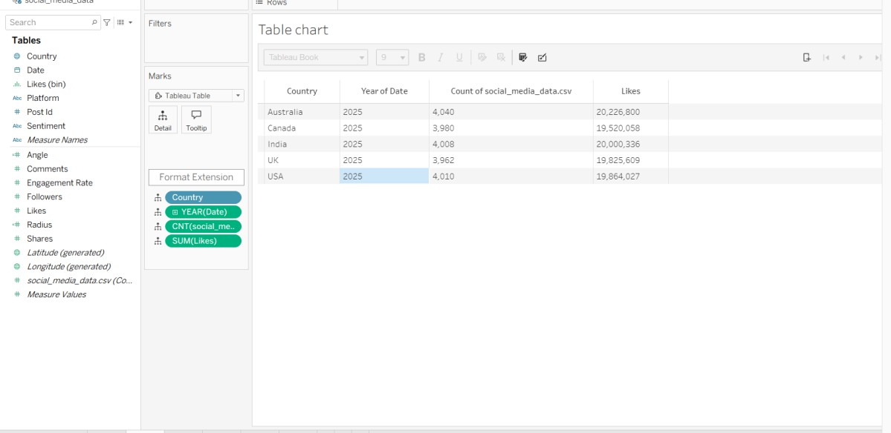

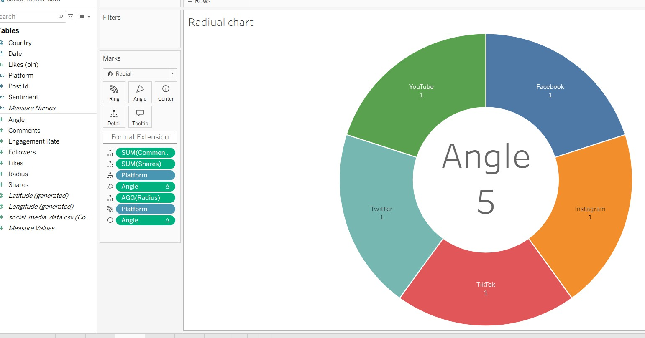

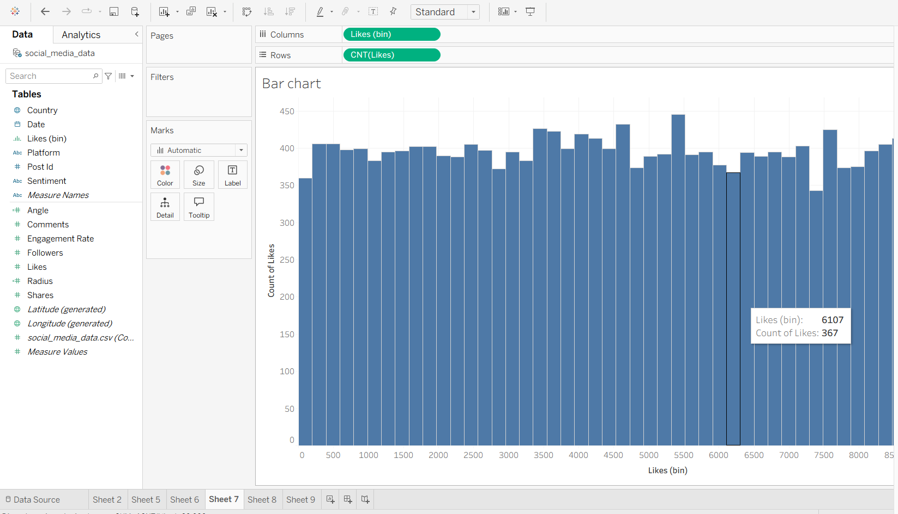

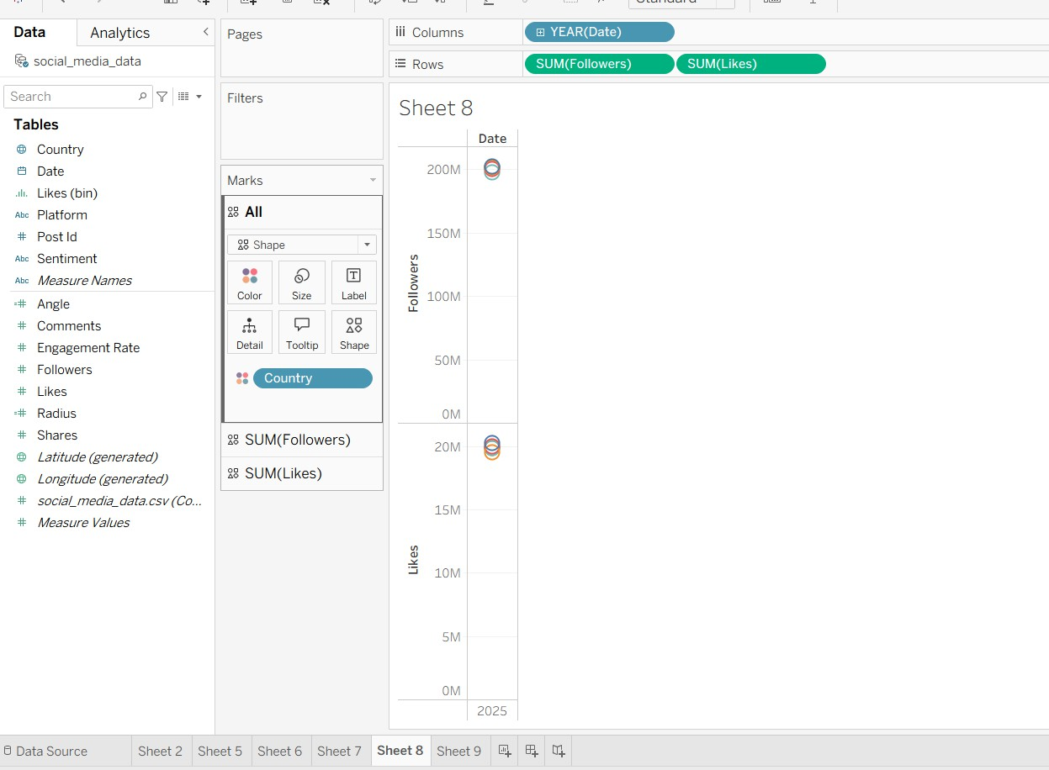

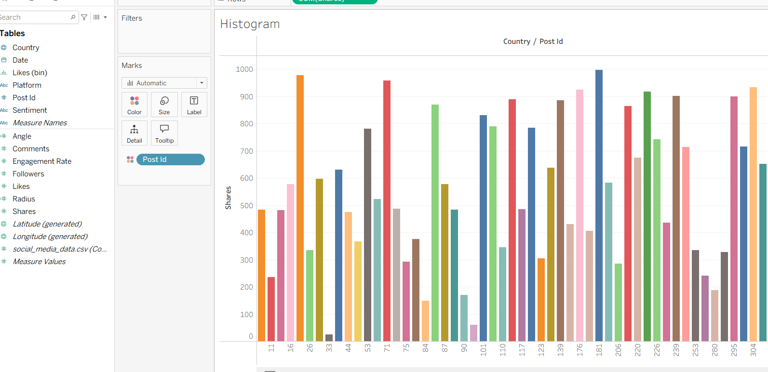

- Dashboard
Combine the visualizations into a single interactive Tableau dashboard.

The dashboard can include filters for:
  - Platform
  - Content Type
  - Date

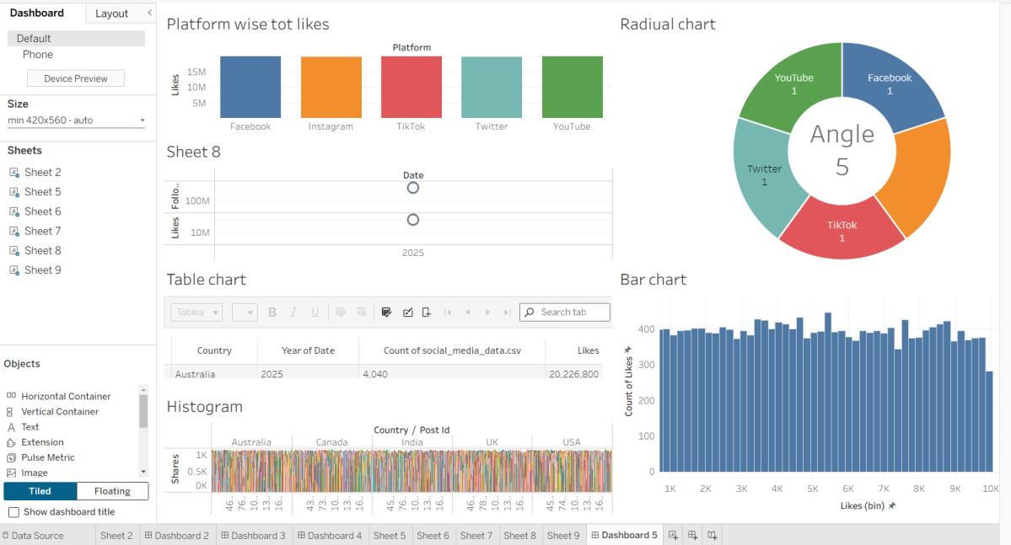

RESULT:
The Social Media Analytics mini project was successfully implemented using Python, SQL Server, and Tableau. A dataset containing exactly 20,000 social media records was generated using Python and stored in SQL Server. The data was successfully analyzed and visualized using Tableau through bar charts, line charts, pie charts, histograms, and box plots. The dashboard provides insights into platform-wise likes, views, engagement rates, content types, and social media performance.
Final Result
20,000 Records Generated
↓
Python Data Processing
↓
CSV Dataset Created

↓
SQL Server Database
↓
20,000 Records Verified
↓
Tableau Connection
↓
Charts & Visualizations
↓
Interactive Dashboard
↓
Social Media Analytics Completed

CONCLUTION:
Thus, the social media dataset was successfully generated, stored, managed, analyzed, and visualized using Python, SQL Server, and Tableau. The project demonstrates how data analytics and visualization techniques can be used to understand social media engagement and identify meaningful patterns in large datasets.

